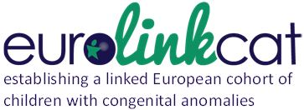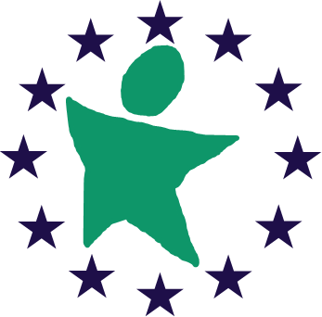

EUROlinkCAT Work package (WP) 5
Educational achievements and needs of children with congenital anomalies
Report summarizing Survey responses

Judith Rankin (lead, UNEW), Svetlana Glinianaia (UNEW)
on behalf of the WP5 team (Amanda Neville, lead, UNIFE)

Background
Survival of children born with congenital anomalies beyond infancy (the first year of life) is improving. Therefore, it is becoming increasingly important to study children’s school performance and their educational needs as there may be a growing population of children and young people requiring additional support and resources in the future. However, apart from the more common genetic syndromes and structural anomalies, the evidence of educational achievements and needs for children with specific congenital anomalies is lacking. The published evidence indicates that children born with congenital anomalies are at a higher risk of lower academic achievements and may require additional support at school. For example, a recent American study reported that a significantly lower percentage of children with congenital heart defects (CHD) after a CHD surgery in infancy achieved grade 3 and 4 proficiency in literacy and mathematics compared with grade-matched state students.¹ These children were more likely to receive special education due to multiple disabilities or mental retardation.² There is further evidence that children with isolated oro-facial clefts were at a greater risk of persistent low achievement at school than their classmates (by 45%, 63% and 73%, for math, reading and language respectively) (Wehby, 2015).³ A study using Wales’ registry (CARIS) data reported that a fifth of girls with Turner syndrome required a significant amount of special education needs and 35% some additional support at school (Iyer, 2011).⁴
Combined data from European registries of congenital anomalies linked to educational data within the WP5 of the EUROlinkCAT study will provide an opportunity to examine educational achievements and needs of children with different congenital anomalies aged 4-10 years.
Aim:
To expand the knowledge on the educational achievements and needs of children with specific congenital anomalies and to provide predictions of future need.
The specific tasks are to:
- Identify the data available on education across countries of Europe and address issues in combining it. (UNEW)
- Determine the educational achievements and needs of children born with a congenital anomaly by congenital anomaly subgroup, including those with multiple anomalies (UNEW)
- Evaluate if educational achievements and needs are associated with clinical (the use of anaesthesia, surgery, days spent in hospital) and sociodemographic factors (gender, maternal age, socioeconomic status) (UNEW)
- To undertake statistical modelling of data to provide predictions of the number of children with congenital anomalies across Europe under 11 years who may have specific educational needs (UNEW)

The survey reported upon here addresses task 1 above. At the time of the funding application, nine registries indicated that they would be able to participate in this WP.
The purpose of the survey
To collect information on the availability of education data since 1995 in each of the 21 registries participating in the EUROlinkCAT project, to investigate if this information could be made available for the linkage with the registry congenital anomaly data and to find out if any other registries would be able to participate in the WP5.
Survey
The survey was a self-reported questionnaire consisting of seven sections containing 25 questions with an option to opt out if no further data was available (see a copy of the blank survey in Appendix). The final questions, i.e. 26-30, were addressed to those registries who had not already volunteered to be involved in WP5 asking them if after they were in touch with their local education authority and completed the survey, they would be able to participate. Sections II-III covered issues in relation to the local school education system in general and data availability, while sections IV-VII covered issues around education tests for children with disability and data availability and access.

The survey was emailed to all registers in May 2017 and closed in July 2017.
Summary of the survey responses
The registry leaders from all 21 EUROCAT registries participating in the EUROlinkCAT project responded to the survey (Table 1). All nine registries who volunteered to be involved in WP5 at the time of the EUROlinkCAT application confirmed their participation in WP5. The Tuscany (Italy) registry responded that the linkage with education data would be possible at extra costs. They will be able to provide the information on the Ethics/governance approval needed and on the costs estimation at a later stage of the project.
The following registries responded ‘No’ to the question “Would it be possible to do the linkage with education data?“ (Table 1)
Belgium: Antwerp, Croatia: Zagreb, France: Paris, France: Ile de la Reunion, Germany: Saxony-Anhalt, Netherlands: North, Portugal: South, Spain: Basque Country, Spain: Valencia, Ukraine: West.
The Malta registry leader’s response in relation to their potential participation was uncertain. The discussions with Malta’s Ministry for Health and the Ministry for Education are ongoing.
A brief summary of the data collected by the survey is presented below.

Education system in general (Table 2, participating registries are highlighted in yellow):
- Age of children when they start school:
Range from 4-5 years in the UK to 7 years in Finland.

- Age of children when they leave primary school
Ranges from 10 y in South Portugal and Ukraine to 15 y in Denmark and Croatia: Zagreb

- Age at the first official exam
As early as 6-7 y in England and Spain: Valencia to as late as 18 y for a high school diploma in Finland, Spain: Basque Country and Croatia: Zagreb;
There are no official exams in obligatory school (7 y to 16 y) in Finland – school grades at the age of 15/16 y; there will also be linked data for those with completed secondary and tertiary education.

- Ages when other official testing takes place until the school leaving age
Greatly varies between the different European regions (see Table 2).

Education for children with disability
- Age of children when they start school
Same ages if they attend public/regular/mainstream school
- Do they have to take exams?
Yes, if attend public/regular/mainstream school (may need special education provision – e.g. UK).
No, if educated at home or special/private schools.
- Age at the first official exam
Same ages if they attend public/regular/mainstream school.
No official exams at obligatory school in Finland.

Availability of Education data
Individual-level data on education are collected in all ten participating registries.
Individual-level data on education are also being collected for children with disability, in particular if they study in a mainstream school. It has to be taken into account that the type of information collected may change over the study period due to changes in the education systems.

Based on the survey responses, ten participating registries are representative of all the 21 European registries that completed the survey. Among both the participating and non-participating regions, the age of children varies to the same extent for all the school stages, i.e. start of the primary school, start of the secondary school, first official exams. Similar to non-participating regions, the participating regions contain the regions where children do not take official exams until the age of 18 years (high school diploma) and those where children take the exams/tests in the primary school.

Next steps
The analysis of the linked education data for children with congenital anomalies will be performed after the Ethics approval is granted for ten participating registries. The aggregated results on the school achievements in the groups of children with specific anomalies will be published - no individual information will be released. These results should increase knowledge on the educational achievements and needs of children with specific congenital anomalies. We will work with the EUROlinkCAT Action Advisory Panel to ensure the best ways for implementation of relevant findings and translation them into policy across Europe.

Table 1. Responses to the WP5 survey by registry

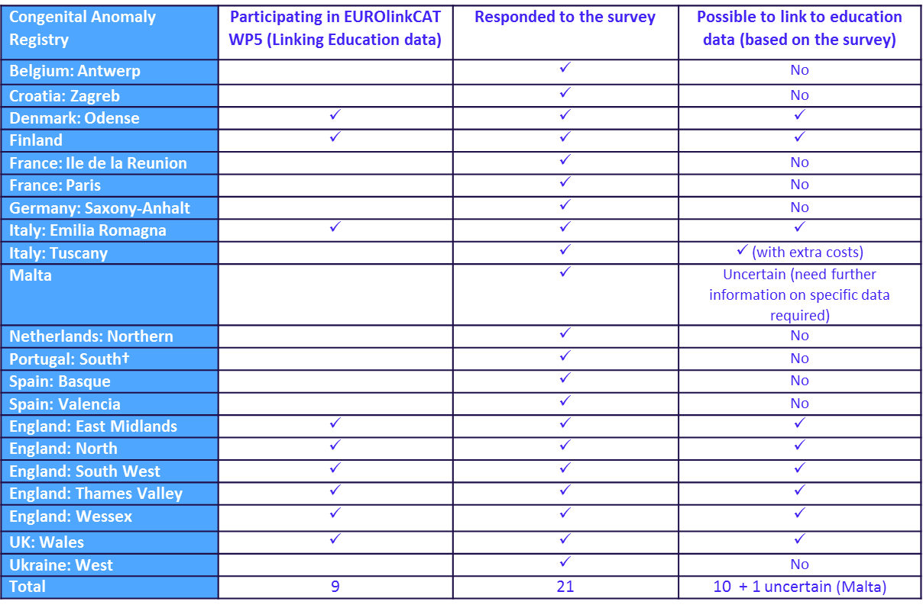
Table 2. Registry leaders’ responses to questions relating to the education system (participating registries are highlighted in yellow)
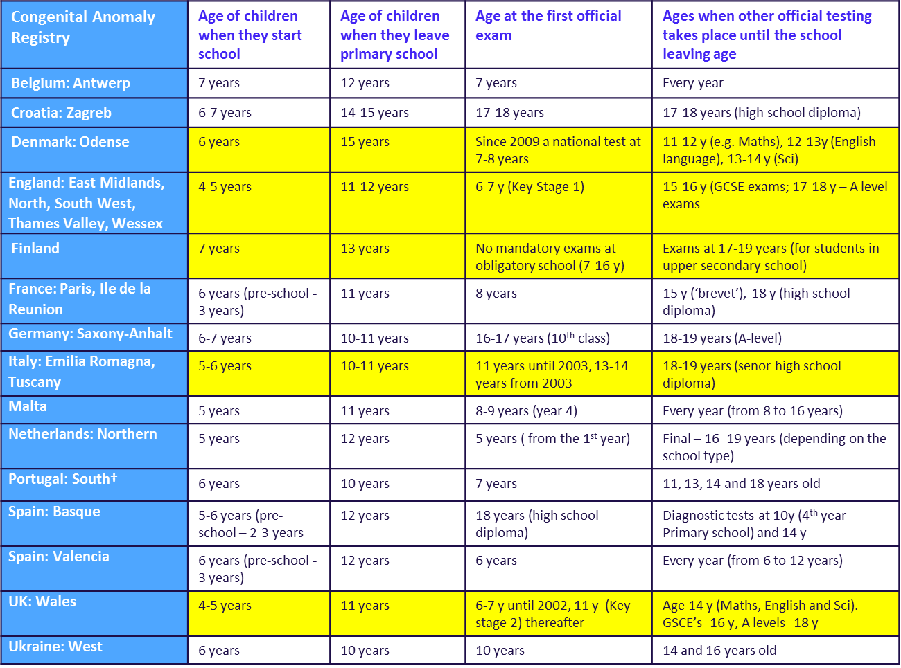

References

1. Mulkey SB, Bai S, Luo C, Cleavenger JE, Gibson N, Holland G, Mosley BS, et al. School-Age Test Proficiency and Special Education After Congenital Heart Disease Surgery in Infancy. J Pediatr 2016;178:47-54 e41.
2. Mulkey SB, Swearingen CJ, Melguizo MS, Reeves RN, Rowell JA, Gibson N, Holland G, et al. Academic proficiency in children after early congenital heart disease surgery. Pediatr Cardiol 2014;35:344-352.
3. Wehby GL, Collett BR, Barron S, Romitti P, Ansley T. Children with oral clefts are at greater risk for persistent low achievement in school than classmates. Arch Dis Child 2015;100:1148-1154.
4. Iyer NP, Tucker DF, Roberts SH, Moselhi M, Morgan M, Matthes JW. Outcome of fetuses with Turner syndrome: a 10-year congenital anomaly register based study. J Matern Fetal Neonatal Med 2012;25:68-73.
Workpackage 5: EDUCATION SURVEY

Workpackage leads: Prof Judith Rankin, Dr Amanda Neville

We would like to know about the availability of data regarding Education in your country or region since 1995 and if this can be made available to the project. Thank you for taking the time to complete this survey.

I Register details
1. Register name
_______________________________________
2. Location of register (Region and Country)
_______________________________________
3. Name and email of the person responsible for completing this survey ___________________________________________________________________________

II Your Education system in general
4a. At what age do children start school in your region?
__________________
4b. At what age do children leave primary (also called first or elementary) school in your region? __________________
5. At what age do the first official* exams take place in your region?
___________________
6. Please give the ages when other official testing takes place until the school leaving age?
__________________________________________________

* By official exams we mean exams that are routine, all children have to take and that the results are recorded.

III Availability of education data
7a. Does your region collect any data on education (please delete as appropriate)?
Yes (go to 7b) No (go to End of survey)
7b. Are individual data on each child collected?
Yes No
8. Over what time period e.g. since 1995, has education data been collected in your region?
____________________________________
9. Which organisation holds this data?
____________________________________
10. Do you currently have any contact(s) with this organisation (please delete as appropriate)?
Yes No
11. Please give the website for the organisation that holds this information if there is one.
___________________________________________

CHILDREN WITH ANY DISABILITY
IV Testing of pupils with any disability
12a. At what age do children with a disability start school in your region?
______________________
12b. At what age do children with a disability leave primary (first or elementary) school in your region?
______________________
13. Do children with a disability take official exams in your region?
______________________
14. Please give the ages when official testing takes place?
______________________

15. Please give the ages when other official testing takes place until the school leaving age?
__________________________________________________

V Availability of education data
16. Does your region collect any data on education for children with a disability (please delete as appropriate)?
Yes (go to Q17) No (go to End of survey)
17. What type of disability is this data collected for?
____________________________________________________________________________
18. Over what time period e.g. since 2011, has education data been collected in your region for children with a disability?
___________________________
19. How is this data used and reported?
____________________________________________________________________________
20. Which organisation holds this data?
___________________________
21. Do you currently have any contact(s) with this organisation?
Yes No
22. Please give the website for the organisation that holds this information if there is one.
___________________________________________

VI Accessing education data
23. Do you know how to access this education data (please delete as appropriate)?
Yes (go to Q24) No (go to End of survey)

24. Do you know who to approach to find out how to access the data (please delete as appropriate)?
Yes No

VII Learning support
25. Is learning support e.g. a learning support teacher, home schooling, available to children with learning support needs in your region (please delete as appropriate)?
a) Learning support teacher Yes No
b) Home schooling Yes No
c) Hospital schooling Yes No

For registers who have not already volunteered to be involved with this project only:
26. If your register has not already volunteered to link education data in the EUROlinkCAT project, do you now think it might be possible to do the linkage (please delete as appropriate)?
Yes No
(There is unlikely to be additional funding at the moment but we would be interested in knowing whether you might be able to do the linkage and, if so, we could investigate trying to obtain funds for this).
27. What permissions/governance would need to be in place to access the data?
__________________________________________________________________
28. What is the cost to access the data?
__________________________________________________________________
29. To link education data to register data on children with congenital anomalies, who would do the linkage?
__________________________________________________________________
30. Is there a cost attached to linking the data?
___________________________________________________________________

Please use the space below for any further comments:

END
Thank you very much for taking the time to complete this survey.
Please return the survey to Nicholas Connor (n.connor@qmul.ac.uk) by Wed. 17th May 2017

